**C - Fourth Sunday of Easter – May 11, 2025**

**The 14th Morontia Appearance on the Capernaum Mount of Ordination to the 11 Apostles on Saturday, April 22, 30 A.D at 12 noon, and**

**The 15th Morontia Appearance by the seaside near Bethsaida to more than 500 on Saturday, April 29, 30 A.D. after 3 p.m.**

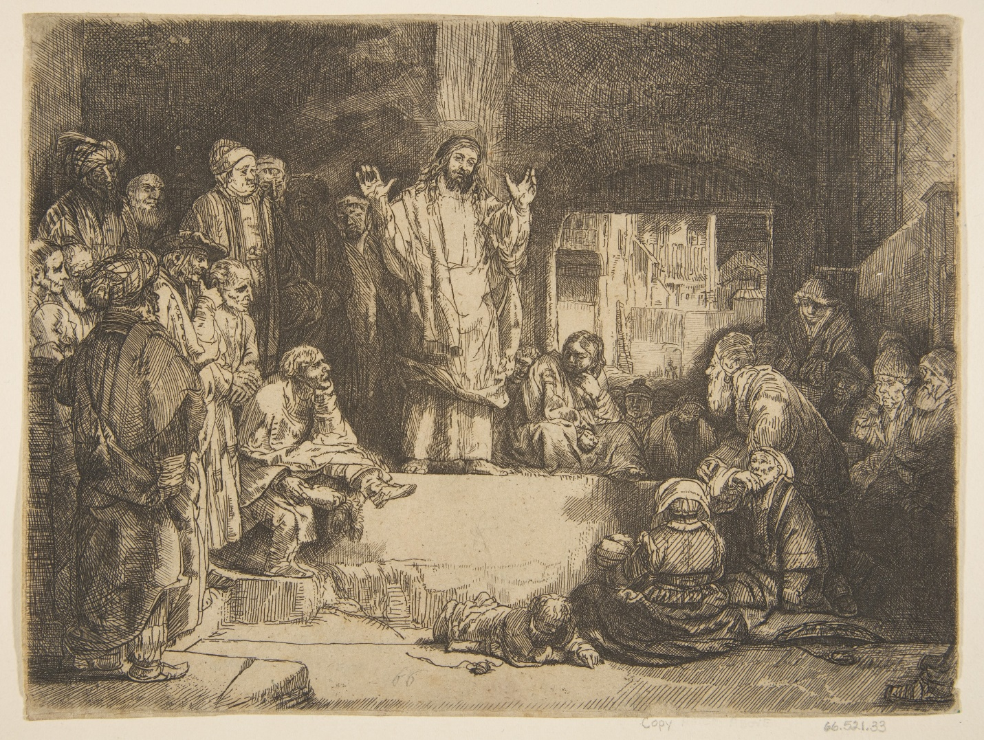

**Rembrandt van Rijn (1606 – 1669) – The Sermon of Jesus (La Petite Tombe) c. 1652**

**Introductory Reflection –** This Rembrandt etching emphasizes Jesus as a teacher and hence his teachings, the subject of the Urantia gospel for today, rather than the 14th and 15th morontia appearances and the “fact” that Jesus rose from the dead. While his resurrection is a fact, the “fact” of his life and teachings has been lost and distorted over the centuries, only to emerge once again in the mid-20th century in an even more comprehensive form.

Rembrandt emphasizes that Jesus taught men and women, rich and poor, particularly he poor in spirit, many beaten down by life, poverty, prejudice and lack of opportunity.

**Urantia, Part IV. The Life and Teachings of Jesus, Paper 192 – Appearances in Galilee, Section 3. On the Mount of Ordination, Paragraph 1 -3**

192:3.1 (2050.1) At noon on Saturday, April 22, the eleven apostles assembled by appointment on the hill near Capernaum, and Jesus appeared among them. This meeting occurred on the very mount where the Master had set them apart as his apostles and as ambassadors of the Father’s kingdom on earth. And this was the Master’s fourteenth morontia manifestation.

192:3.2 (2050.2) At this time the eleven apostles knelt in a circle about the Master and heard him repeat the charges and saw him re-enact the ordination scene even as when they were first set apart for the special work of the kingdom. And all of this was to them as a memory of their former consecration to the Father’s service, except the Master’s prayer. When the Master—the morontia Jesus—now prayed, it was in tones of majesty and with words of power such as the apostles had never before heard. Their Master now spoke with the rulers of the universes as one who, in his own universe, had had all power and authority committed to his hand. And these eleven men never forgot this experience of the morontia rededication to the former pledges of ambassadorship. The Master spent just one hour on this mount with his ambassadors, and when he had taken an affectionate farewell of them, he vanished from their sight.

192:3.3 (2050.3) And no one saw Jesus for a full week. The apostles really had no idea what to do, not knowing whether the Master had gone to the Father. In this state of uncertainty they tarried at Bethsaida. They were afraid to go fishing lest he come to visit them and they miss seeing him. During this entire week Jesus was occupied with the morontia creatures on earth and with the affairs of the morontia transition which he was experiencing on this world.[1]

**Reflection –** As they knelt at their ordination side, Jesus’s majesty and power shown through. While he was now undisputed ruler of a vast universe, the 11 apostles had grown spiritually since their ordination a little over three years before. They could now appreciate Jesus better.

**Responsorial Psalm -** [**Psalm 100:1-2, 3, 5**](https://bible.usccb.org/bible/Psalms/100?1) [2]  **R.(3c)** “**We are shepherded by heavenly guidance.”**

“Shout out with joy, all who live on earth. Serve the Holy One with rejoicing. Come before the Upholder with a ringing cry. Know that God is a source of wonder.”   
**R.** **“We are shepherded by heavenly guidance.”**

”You created us, and it to our Creator we belong. We are shepherded by heavenly guidance.”   
**R.** **“We are shepherded by heavenly guidance.”**

“Be thankful, awed by the Holy Name. For God is good; your kindness is toward the world. From generation to generation, you remain faithful.” **R.** **“We are shepherded by heavenly guidance.” [3]**

**Reflection –** May we always turn toward God for heavenly guidance. What a beautiful, poetic, comforting way to think that we are shepherded by God’s guidance, which we are.

**Reading 2 -** **Urantia, Part IV. The Life and Teachings of Jesus, Paper 192 – Appearances in Galilee, Section 4. The Lakeside Gathering, Paragraphs 1 – 3**

192:4.1 (2050.4) Word of the appearances of Jesus was spreading throughout Galilee, and every day increasing numbers of believers arrived at the Zebedee home to inquire about the Master’s resurrection and to find out the truth about these reputed appearances. Peter, early in the week, sent out word that a public meeting would be held by the seaside the next Sabbath at three o’clock in the afternoon.

192:4.2 (2050.5) Accordingly, on Saturday, April 29, at three o’clock, more than five hundred believers from the environs of Capernaum assembled at Bethsaida to hear Peter preach his first public sermon since the resurrection. The apostle was at his best, and after he had finished his appealing discourse, few of his hearers doubted that the Master had risen from the dead.

192:4.3 (2050.6) Peter ended his sermon, saying: “We affirm that Jesus of Nazareth is not dead; we declare that he has risen from the tomb; we proclaim that we have seen him and talked with him.” Just as he finished making this declaration of faith, there by his side, in full view of all these people, the Master appeared in morontia form and, speaking to them in familiar accents, said, “Peace be upon you, and my peace I leave with you.” When he had thus appeared and had so spoken to them, he vanished from their sight. This was the fifteenth morontia manifestation of the risen Jesus.[4]

**Reflection –** This appearance was by far the briefest, but it must have been well-known as it was recorded by Paul in **1 Corinthians 15:3.6** “Then he appeared to more than five hundred brothers and sisters at one time, most of whom are still alive, though some have died.”

**Alleluia –** [**Urantia 192:4.8**](https://bible.usccb.org/bible/john/10?14) **R. Alleluia, alleluia.**

And so, under the vigorous leadership of Peter and ere the Master ascended to the Father, his well-meaning representatives began that subtle process of gradually and certainly changing the religion *of* Jesus into a new and modified form of religion *about* Jesus.  
**R. Alleluia, alleluia.[5]**

**Gospel - Urantia, Part IV. The Life and Teachings of Jesus, Paper 192 – Appearances in Galilee, Section 4. The Lakeside Gathering, Paragraphs 4 - 8**

192:4.4 (2051.1) Because of certain things said to the eleven while they were in conference with the Master on the mount of ordination, the apostles received the impression that their Master would presently make a public appearance before a group of the Galilean believers, and that, after he had done so, they were to return to Jerusalem. Accordingly, early the next day, Sunday, April 30, the eleven left Bethsaida for Jerusalem. They did considerable teaching and preaching on the way down the Jordan, so that they did not arrive at the home of the Marks in Jerusalem until late on Wednesday, May 3.

192:4.5 (2051.2) This was a sad home-coming for John Mark. Just a few hours before he reached home, his father, Elijah Mark, suddenly died from a hemorrhage in the brain. Although the thought of the certainty of the resurrection of the dead did much to comfort the apostles in their grief, at the same time they truly mourned the loss of their good friend, who had been their stanch supporter even in the times of great trouble and disappointment. John Mark did all he could to comfort his mother and, speaking for her, invited the apostles to continue to make their home at her house. And the eleven made this upper chamber their headquarters until after the day of Pentecost.

192:4.6 (2051.3) The apostles had purposely entered Jerusalem after nightfall that they might not be seen by the Jewish authorities. Neither did they publicly appear in connection with the funeral of Elijah Mark. All the next day they remained in quiet seclusion in this eventful upper chamber.

192:4.7 (2051.4) On Thursday night the apostles had a wonderful meeting in this upper chamber and all pledged themselves to go forth in the public preaching of the new gospel of the risen Lord except Thomas, Simon Zelotes, and the Alpheus twins. Already had begun the first steps of changing the gospel of the kingdom—sonship with God and brotherhood with man—into the proclamation of the resurrection of Jesus. Nathaniel opposed this shift in the burden of their public message, but he could not withstand Peter’s eloquence, neither could he overcome the enthusiasm of the disciples, especially the women believers.

192:4.8 (2051.5) And so, under the vigorous leadership of Peter and ere the Master ascended to the Father, his well-meaning representatives began that subtle process of gradually and certainly changing the religion *of* Jesus into a new and modified form of religion *about* Jesus.[6]

**Reflection –** Given all they had been through and that they were only men, still fearful of the Jewish leaders and surrounded by death, it is understandable how Peter and most of the apostles latched on to and realized the power of Jesus’s resurrection. Peter and then Paul created an embellished theology around that “fact”. This made their story *about Jesus,* rather than telling the story *of Jesus* and his teachings..

It is interesting to speculate about how different the teachings *of Jesus* would be today and how different our lives would be, if they had laid emphasis on who he was and what he taught. Namely, Jesus’s loving Father is our Father, and that we are all brothers and sisters. Since the arrival of the Spiritual of Truth from and through Jesus at Pentecost all human beings on earth can connect to its influences. This can readily be seen today. Also, since Pentecost all normal human minds around the age of 5 years are bestowed with a Thought Adjuster, a particle of God the Father. The Thought Adjuster can guides us through the labyrinth of life on our journey to be like him, world after world, until we, transformed, meet him, face to face in Paradise, if we listen to and embrace his guidance.

1. **Replaced Reading 1 -** [**Acts 13:14, 43-52**](https://bible.usccb.org/bible/acts/13?14)

   Paul and Barnabas continued on from Perga and reached Antioch in Pisidia. On the sabbath they entered the synagogue and took their seats. Many Jews and worshipers who were converts to Judaism followed Paul and Barnabas, who spoke to them and urged them to remain faithful to the grace of God.  
     
   On the following sabbath almost the whole city gathered to hear the word of the Lord. When the Jews saw the crowds, they were filled with jealousy and with violent abuse contradicted what Paul said. Both Paul and Barnabas spoke out boldly and said, “It was necessary that the word of God be spoken to you first, but since you reject it and condemn yourselves as unworthy of eternal life, we now turn to the Gentiles. For so the Lord has commanded us, *I have made you a light to the Gentiles, that you may be an instrument of salvation to the ends of the earth.”*  
     
   The Gentiles were delighted when they heard this and glorified the word of the Lord. All who were destined for eternal life came to believe, and the word of the Lord continued to spread  
   through the whole region. The Jews, however, incited the women of prominence who were worshipers and the leading men of the city, stirred up a persecution against Paul and Barnabas,  
   and expelled them from their territory. So they shook the dust from their feet in protest against them, and went to Iconium. The disciples were filled with joy and the Holy Spirit.
2. After and inspired by Pamela Greenberg’s **The Complete Psalms – The Book of Prayer Songs in a New Translation.**
3. **Replaced Responsorial Psalm -** [**Psalm 100:1-2, 3, 5**](https://bible.usccb.org/bible/Psalms/100?1)  **R.(3c)** **We are his people, the sheep of his flock.**

   Sing joyfully to the LORD, all you lands; serve the LORD with gladness; come before him with joyful song.  
   **R.** **We are his people, the sheep of his flock.**

   Know that the LORD is God; he made us, his we are; his people, the flock he tends.  
   **R.** **We are his people, the sheep of his flock.**

   The LORD is good: his kindness endures forever, and his faithfulness, to all generations.  
   **R.** **We are his people, the sheep of his flock.**  
   
4. **Replaced Reading 2 -** [**Revelation 7:9, 14b-17**](https://bible.usccb.org/bible/Revelation/7?9)

   I, John, had a vision of a great multitude, which no one could count, from every nation, race, people, and tongue. They stood before the throne and before the Lamb, wearing white robes and holding palm branches in their hands.

   Then one of the elders said to me, “These are the ones who have survived the time of great distress; they have washed their robes and made them white in the blood of the Lamb.

   “For this reason they stand before God’s throne and worship him day and night in his temple. The one who sits on the throne will shelter them. They will not hunger or thirst anymore, nor will the sun or any heat strike them. For the Lamb who is in the center of the throne will shepherd them and lead them to springs of life-giving water, and God will wipe away every tear from their eyes.”
5. **Replaced** **Alleluia -** [**John 10:14**](https://bible.usccb.org/bible/john/10?14) **R. Alleluia, alleluia.**

   I am the good shepherd, says the Lord; I know my sheep, and mine know me.  
   **R. Alleluia, alleluia.**
6. **Replaced Gospel -** [**John 10:27-30**](https://bible.usccb.org/bible/john/10?27)

   Jesus said: “My sheep hear my voice; I know them, and they follow me. I give them eternal life, and they shall never perish. No one can take them out of my hand. My Father, who has given them to me, is greater than all, and no one can take them out of the Father’s hand. The Father and I are one.”